 Project Report Template

1. **INTRODUCTION**

Create a social media post using canva

* 1. Overview

Design in canva then use content planner to plan schedule and publish social media posts directly to your favourite platforms.

* 1. Purpose

Social media helps your strengthen your brand and expand its

Reach and affordable ways to introduce your brand to the world.

1. **Problem Definition & Design Thinking**

Creating content for social media easy with thousands of templates for every social channels, a drag and drop- editor graphics, fonts, shapes and more!

**2.1 Empathy map**

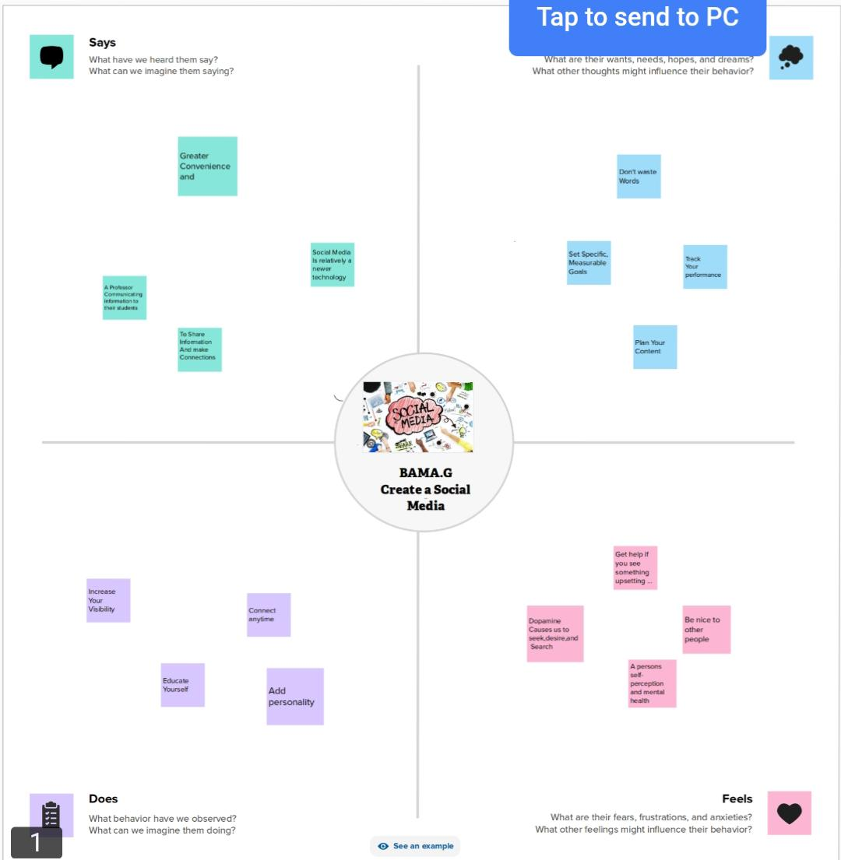**2.2 Ideation & Brainstorming Map**

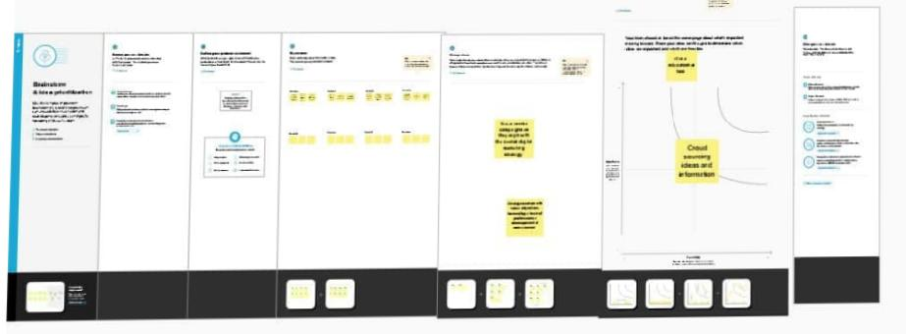

1. **Result**

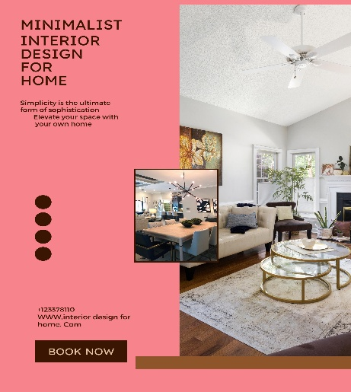

1. **Advantages**

Social media promotes creativity.

Increase sales opportunities.

**Disadvantages**

Decrease in communication skills.

Getting close to depression.

1. **APPLICATIONS**

I submit this application to express my sincere interest in the interior design for home

1. **CONCLUSION**

We learn a lot of new things about Editing and make it useful

For others.

 Project Report Template